**Assignment V**

Name :- Bibek Chand Sah

Roll :- 22054029

Branch :- CSE

Section :- CSE-05

1. Find the average salary of each department.

🡺 SELECT dept, AVG(salary) AS average_salary FROM employee GROUP BY dept;

2. Find the average salary for each jobtype according to each department.

🡺 SELECT dept, job_types, AVG(salary) AS average_salary FROM employee GROUP BY dept, job_types;

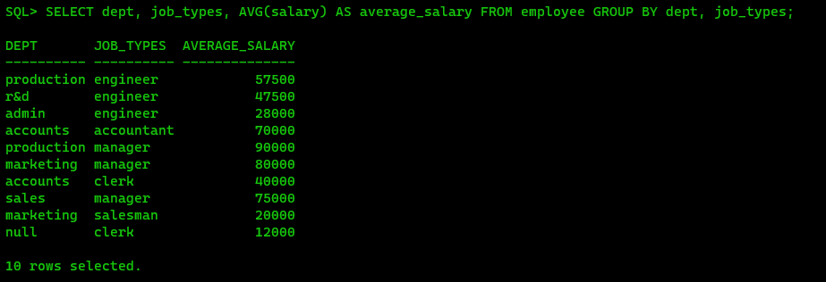

3. Find the department names and their corresponding average salary where the average

salary is greater than 40000.

🡺 SELECT dept, AVG(salary) AS average_salary FROM employee GROUP BY dept HAVING AVG(salary) > 40000;

4. Select the departments where the maximum salary is more than 55000.

🡺 SELECT dept FROM employee GROUP BY dept HAVING MAX(salary) > 55000;

5. Find the department names and their average salary where the maximum salary of the

department is higher than 55000.

🡺 SELECT dept, AVG(salary) AS average_salary FROM employee GROUP BY dept HAVING MAX(salary) > 55000;

6. Display the job_types and the total monthly salary for each jobtypes as “PAYROLL”, where

the total payroll according to jobtypes exceeds 100000/month.

🡺 SELECT job_types, SUM(salary) AS total_salary FROM employee GROUP BY job_types HAVING SUM(salary) > 100000;

7. Display the job_types and the total monthly salary for each jobtypes as “PAYROLL”, where

the total payroll according to jobtypes exceeds 100000/month and jobtype is not engineer.

🡺 SELECT job_types, SUM(salary) AS total_salary FROM employee WHERE job_types != 'engineer' GROUP BY job_types HAVING SUM(salary) > 100000;

8. Display the job_types and the total monthly salary for each jobtypes as “PAYROLL”, where

the total payroll according to jobtypes exceeds 60000/month and jobtype is not engineer

and sort the list in ascending order of sum of salary.

🡺 SELECT job_types, SUM(salary) AS total_salary FROM employee WHERE job_types != 'engineer' GROUP BY job_types HAVING SUM(salary) > 60000 ORDER BY SUM(salary) ASC;

9. Display the job_types and the total monthly salary for each jobtypes as “PAYROLL”, where

the total payroll according to jobtypes exceeds 50000/month and jobtype is not engineer

and sort the list in descending order of sum of salary.

🡺 SELECT job_types, SUM(salary) AS total_salary FROM employee WHERE job_types != 'engineer' GROUP BY job_types HAVING SUM(salary) > 50000 ORDER BY SUM(salary) DESC;

10. Find the maximum average salary according to departments.

🡺 SELECT DEPT, AVG_SALARY AS MAX_AVG_SALARY FROM (SELECT DEPT, AVG(SALARY) AS AVG_SALARY FROM EMPLOYEE GROUP BY DEPT) Subquery WHERE AVG_SALARY = (SELECT MAX(AVG_SALARY) FROM (SELECT AVG(SALARY) AS AVG_SALARY FROM EMPLOYEE GROUP BY DEPT ));

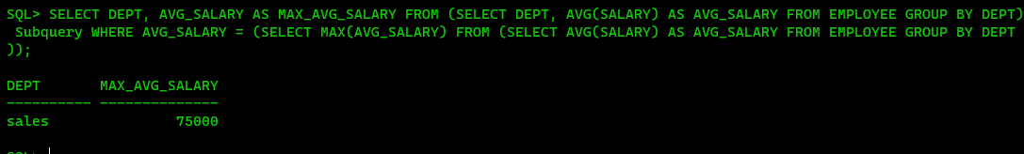

11. Find the minimum average salary according to jobtypes.

🡺 SELECT MIN(AVG(SALARY)) AS MIN_AVG_SALARY FROM EMPLOYEE GROUP BY JOB_TYPES;

12. Find the employee name and date of joining who are working in delhi.

🡺 SELECT e.FIRST_NAME || ' ' || e.LAST_NAME AS EMPLOYEE_NAME, e.DOJ FROM EMPLOYEE e JOIN DEPARTMENT d ON e.DEPT = d.D_NAME WHERE d.D_LOC = 'delhi';

13. Create the table ‘Emp_Address’ for storing the permanent address of the employees and

insert the values.

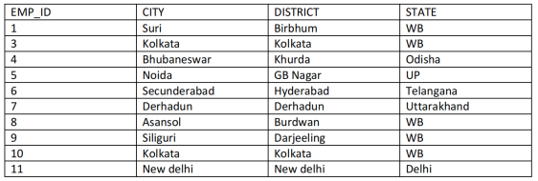

🡺 CREATE TABLE Emp_Address (emp_id INT, city VARCHAR(15), district VARCHAR(15), state VARCHAR(15));

INSERT INTO Emp_Address VALUES (&emp_id, '&city', '&district', '&state');

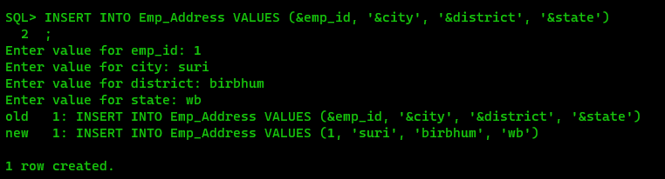

14. Display the employee name with their home city and the city they work in.

🡺 SELECT e.FIRST_NAME || ' ' || e.LAST_NAME AS Employee_Name, a_home.City AS Home_City, d.D_LOC AS Working_City FROM EMPLOYEE e JOIN EMP_ADDRESS a_home ON e.EMP_ID = a_home.EMP_ID JOIN DEPARTMENT d ON e.DEPT = d.D_NAME;

15. Create the following Job_Grades table.

🡺 CREATE TABLE JOB_GRADES (GRADE VARCHAR2(5), LOWEST_SAL NUMBER(10), HIGHEST_SAL NUMBER(10));

INSERT INTO JOB_GRADES VALUES('A',10000,24999);

INSERT INTO JOB_GRADES VALUES('B',25000,49999);

INSERT INTO JOB_GRADES VALUES('C',50000,100000);

16. Display the employee names along with their salary and job_grade.

🡺 SELECT e.FIRST_NAME || ' ' || e.LAST_NAME AS EMPLOYEE_NAME, e.SALARY, j.GRADE FROM EMPLOYEE e JOIN JOB_GRADES j ON e.SALARY BETWEEN j.LOWEST_SAL AND j.HIGHEST_SAL;

17. Display the employees name along with their manager’s name. (use SELF JOIN)

🡺 SELECT e1.FIRST_NAME AS Employee_Name, e2.FIRST_NAME AS Manager_Name FROM EMPLOYEE e1 JOIN EMPLOYEE e2 ON e1.MANAGER_ID = e2.EMPLOYEE_ID;

18. Display emp_id, f_name, d_loc, and hod_id (using natural join).

🡺 SELECT EMPLOYEE.EMPLOYEE_ID, EMPLOYEE.FIRST_NAME, DEPARTMENT.D_LOC, DEPARTMENT.HOD_ID FROM EMPLOYEE NATURAL JOIN DEPARTMENT;

19. Display the employees f_name, city and state in which they live (using natural join).

🡺 SELECT EMPLOYEE.FIRST_NAME, EMP_ADDRESS.CITY, EMP_ADDRESS.STATE FROM EMPLOYEE NATURAL JOIN EMP_ADDRESS;

20. Display the employees emp_id, f_name, d_loc, hod_id using inner join.

🡺 SELECT EMPLOYEE.EMPLOYEE_ID, EMPLOYEE.FIRST_NAME, DEPARTMENT.D_LOC, DEPARTMENT.HOD_ID FROM EMPLOYEE INNER JOIN DEPARTMENT ON EMPLOYEE.DEPT = DEPARTMENT.D_NAME;

21. Display the employees f_name, city and state in which they live (using inner join).

🡺 SELECT EMPLOYEE.FIRST_NAME, EMP_ADDRESS.CITY, EMP_ADDRESS.STATE FROM EMPLOYEE INNER JOIN EMP_ADDRESS ON EMPLOYEE.EMP_ID = EMP_ADDRESS.EMP_ID;

22. Display the employees f_name, city and state in which they live (using join keyword).

🡺 SELECT EMPLOYEE.FIRST_NAME, EMP_ADDRESS.CITY, EMP_ADDRESS.STATE FROM EMPLOYEE JOIN EMP_ADDRESS ON EMPLOYEE.EMP_ID = EMP_ADDRESS.EMP_ID;

23. Insert the following two rows in the employee table without inserting any value in the

department field.

🡺 INSERT INTO EMPLOYEE VALUES(20,'ALEX',NULL,'ENGINEER',28000,2000,NULL,1,TO_DATE('31-JAN-2017','DD-MM-YYYY'));

INSERT INTO EMPLOYEE VALUES(21,'PRIYA','PATEL','CLERK',12000,500,NULL,1,TO_DATE('01-APR-2017','DD-MM-YYYY'));

24. Insert the following two rows into the department table.

🡺 INSERT INTO DEPARTMENT VALUES('TRAINING','MUMBAI',1);

INSERT INTO DEPARTMENT VALUES('PLACEMENT','MUMBAI',1);

25. Display the employees f_name, city and state in which they live after joining employee

and employee_address table using left outer join.

🡺 SELECT EMPLOYEE.FIRST_NAME, EMP_ADDRESS.CITY, EMP_ADDRESS.STATE FROM EMPLOYEE LEFT JOIN EMP_ADDRESS ON EMPLOYEE.EMP_ID = EMP_ADDRESS.EMP_ID;

26. Display the employees f_name and their work location after joining employee and

department table using left join.

🡺 SELECT EMPLOYEE.FIRST_NAME, DEPARTMENT.D_LOC AS WORK_LOCATION FROM EMPLOYEE LEFT JOIN DEPARTMENT ON EMPLOYEE.DEPT = DEPARTMENT.D_NAME;

27. Display the employees f_name and their work location after joining employee and

department table using right join.

🡺 SELECT EMPLOYEE.FIRST_NAME, DEPARTMENT.D_LOC AS WORK_LOCATION FROM EMPLOYEE RIGHT JOIN DEPARTMENT ON EMPLOYEE.DEPT = DEPARTMENT.D_NAME;

28. Display the employees f_name and their work location after joining employee and

department table using full join/full outer join.

🡺 SELECT EMPLOYEE.FIRST_NAME, DEPARTMENT.D_LOC AS WORK_LOCATION FROM EMPLOYEE FULL JOIN DEPARTMENT ON EMPLOYEE.DEPT = DEPARTMENT.D_NAME;

29. Find the employees who are working in their home city.

🡺 SELECT e.EMP_ID, e.FIRST_NAME, e.LAST_NAME FROM EMPLOYEE e JOIN DEPARTMENT d ON e.DEPT = d.D_NAME JOIN EMP_ADDRESS ea ON e.EMP_ID = ea.EMP_ID WHERE d.D_LOC = ea.CITY;

30. Find the job type having the minimum average salary according to jobtypes.

🡺 SELECT JOB_TYPE, AVG(SALARY) AS AVERAGE_SALARY FROM EMPLOYEE GROUP BY JOB_TYPE ORDER BY AVG(SALARY) ASC FETCH FIRST 1 ROW ONLY;